Alcohol problem profiles for the City of Edinburgh Neighbourhood Partnerships

Portobello/Craigmillar
August 2013

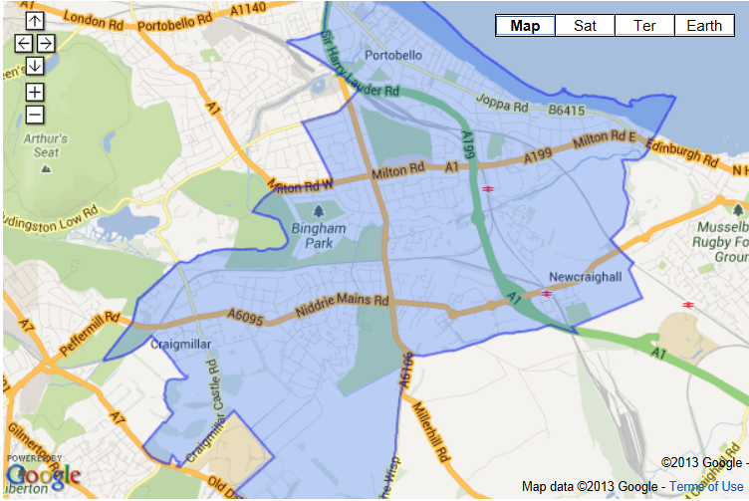

Introduction
The Neighbourhood Partnership area of Portobello/Craigmillar is located in the east of the City. The area covers the intermediate zones of South East Bypass; Greendykes & Niddrie Mains; Niddrie; Jewel, Brunstane & Newcraighall; Bingham, Magdalene &The Christians; Joppa; and Portobello. There are approximately 24,130 people living in Portobello/Craigmillar. The area has significantly poorer rates of employment, health, crime and education, training and skills and slightly poorer rates of housing than the rest of Scotland. Niddrie and Craigmillar have been highlighted as having significantly poorer outcomes for health, including alcohol-related hospital admissions, and crime, including violence, minor assault and vandalism.

The purpose of this report is to provide a summary of how alcohol might affect the area, based on evidence gathered for a larger report on overprovision. Data for the area is available in terms of licensed premises, alcohol-related hospital admissions, fires in which alcohol or drugs are recorded, road traffic accidents, and alcohol-related crimes.

Profile – Edinburgh City
- Edinburgh has a high rate of licensed premises, with 39.0 licensed premises per 10,000 residents.

- 47% of adults in Edinburgh report drinking outwith the Government guidelines.

- Young people in Edinburgh are more likely to report binge drinking than the rest of Scotland.

- Pedestrians who are drunk are more likely to be involved in a collision in areas with higher provision of licensed premises, particularly the City Centre.

- Alcohol-related discharges in Edinburgh are higher than in Midlothian and East Lothian, where they are reducing. In Edinburgh, 91% of all alcohol-related hospital admissions were emergency admissions, with a peak in admissions on Sundays.

- Edinburgh has the highest mortality rate for deaths in which alcohol is the main cause (such as alcoholic liver disease) and for those in which it is a factor (such as certain cancers).

- Edinburgh has the highest number of assaults to ambulance staff, making it the “most dangerous place” for paramedics in Scotland.

- There are seven areas which have high rates of on-sales and off-sales premises, alcohol-related hospital admissions and alcohol-related crimes.

Profile – Portobello/Craigmillar
- There are a total of 68 licensed premises in Portobello/Craigmillar, 38 on-sales (of which 12 are pubs) and 30 off-sales (of which 14 are convenience stores)

- There are 17.5 on-sales premises per 10,000 residents over the age of 18, which is lower than the Edinburgh rate of 39.0; there are 13.8 off-sales premises per 10,000 residents which is higher than the rate for Edinburgh of 10.4

- Portobello/Craigmillar has higher alcohol-related hospital admissions rates per 10,000 residents than the Edinburgh average (134.8 per 10,000 residents compared to 89.4), and has the highest rate in the city, as shown in figure 1

Figure 1. Alcohol-related hospital admissions per 10,000 of the population by neighbourhood partnership area and Edinburgh average (GROS/ScotPHO/HIU)

- Alcohol-related hospital admissions per 10,000 residents are much higher in Greendykes & Niddrie Mains (215.3), Niddrie (201.3) and Bingham, Magdalene & The Christians (185.8)
- Of the 77 fires that occurred in Edinburgh where people were suspected to be under the influence, 25 (32%) occurred in Portobello/Craigmillar, of whom 14 (56%) were injured or had to be rescued. The only fatality occurred in Portobello/Craigmillar.

- Three of the 84 incidents in which a drunk pedestrian was injured in a collision with a motor vehicle occurred in Portobello/Craigmillar

- A total of 30 road traffic accidents occurred in Edinburgh in which alcohol was involved, none of which were in Portobello/Craigmillar

- Alcohol-related crimes are slightly higher in Portobello/Craigmillar than the Edinburgh average, with 131.3 and 106.5 per 10,000 residents, respectively

- Greendykes and Niddrie Mains have one of the highest rates of alcohol-related crimes in the whole city, with 476.0 per 10,000 residents

- Table 1 shows the rates per 10,000 residents of on-sales premises, off-sales premises, alcohol-related hospital admissions and alcohol-related crimes

Table 1. Licensed premises, alcohol-related hospital admissions and alcohol-related crimes per intermediate zone, areas highlighted in red are higher than those for Edinburgh as a whole (Police Scotland/ GROS/ScotPHO/HIU)
 | On-sales per 10,000 population | Off-sales per 10,000 population | Alcohol-related hospital admissions per 10,000 population | Alcohol-related crimes per 10,000 population
Edinburgh City | 27.5 | 10.4 | 89.4 | 106.5
Portobello/Craigmillar NP | 17.5 | 13.8 | 134.8 (mean) | 131.3
South East Bypass | 8.5 | 0 | 58.3 | 19.6
Greendykes & Niddrie Mains | 6.6 | 16.6 | 215.3 | 476.0
Niddrie | 0 | 6.0 | 201.3 | 183.6
Jewel, Brunstane & Newcraighall | 13.9 | 21.0 | 102.3 | 49.4
Bingham, Magdalene &The Christians | 3.0 | 8.9 | 185.8 | 96.4
Joppa | 19.9 | 6.6 | 69.9 | 28.8
Portobello | 63.8 | 24.9 | 110.6 | 130.0

- Seven areas of the city have been identified as being highly problematic in terms of the density of licensed premises and alcohol-related harm; Portobello is one of these areas

Conclusions
Portobello/Craigmillar has a number of problems affecting the area in terms of alcohol use. There are high rates of off-licensed premises, which are thought to be more problematic in terms of excessive alcohol consumption than on-sales due to lower priced alcohol, and fewer restrictions around consumption. On-sales licensed premises provide alcohol in specific measures and will stop serving someone if they are intoxicated, while the amount of alcohol consumed at home is controlled by the drinker. The high rates of alcohol-related hospital admissions, particularly in Greendykes & Niddrie Mains, Niddrie and Bingham, Magdalene & The Christians may be due to high rates of deprivation. Alcohol-related crime rates in Greendykes & Niddrie Mains are far higher than the average for Edinburgh and for Portobello/Craigmillar.

Report prepared by: Hannah Carver, Research and Evaluation Officer, Edinburgh ADP Support Team on behalf of the Edinburgh ADP Overprovision Steering Group. Hannah.Carver@edinburgh.gov.uk

Intermediate zones (IZ) were created for use with Scottish Neighbourhood Statistics (SNS) as a level between data zones (500 to 1000 people) and large scale local authorities. IZs contain between 2500 and 6000 people (Source:http://www.scotland.gov.uk/Publications/2005/02/20732/53083)

